imd-X-XXXX-T
01.09.2009

Teaching Note

by Professor Stuart Read and

Professor Saras Sarasvathy, University of Virginia, DardenSchool of Business

Session Overview
When we poll entrepreneurship classes about why students have not already started a venture (or why they are in the classroom instead of being out there getting that new venture going), the most common answer we get is “I don’t have a good idea.”. (The second most common answer is “I don’t have any money.”, and the third is “I am afraid of failing.”) This session is designed to help entrepreneurship students or students in a starting new ventures class generate startup ideas. The underlying approach is to place some constraints on the students, to enable them to focus on a particular area instead of being overwhelmed by the sea of possible potential opportunities, and see how easy it is to come up with good ideas.
The session does not require any case or preparation on the part of the students. It is scaleable in terms of time by adding topics and extending the discussion, but this teaching note provides timing for a 90-minute session.
Copyright © 2009 by IMD - International Institute for Management Development, Lausanne, Switzerland. Not to be used or reproduced without written permission directly from IMD.

Preparation
The only preparation necessary is identifying materials to provide constraints for the students. We use news stories. Our criteria for choosing stories is as follows; stories must be:
- Current
- Short (a couple of paragraphs, and certainly not more than a page)
- Diverse (no two should touch the same industry, there should be a mix of B2B and B2C, some should be simple, and some complex)
- Some should be positive (technology generating an opportunity) and some should be negative (identification of a problem that could be valuably solved)
- Interesting (to us at least – something we want to talk about)
A sample of 7 stories used in April 2009 is provided in the Appendix (1-7), with all copyrights being the property of their respective owners.
We printed each story on a different color of paper, and shuffled them all together, making sure that we had enough so that each student could have one story (note that we did not hand out all stories to all students).

Timing for a 90-Minute Session
Time | Action
0:00 – 0:05 | Hand out news stories (one per person, take whatever is on top):
0:05 – 0:10 | Introduce session, give students 10 minutes to read their story and produce a one sentence description of a business they could reasonably pursue, based on an idea they got from their news story, and the first thing they would do to pursue the idea
0:10 – 0:20 | Reading
0:20 – 0:25 | Choose a student at random. Ask them to brief the class on their news story, and then describe a business they could reasonably pursue, based on an idea they got from their news story.
0:25 – 0:30 | Ask the student to talk about the first thing they would do to pursue the idea  This is a little bit of a setup as most students will automatically default to “I would do some market research”. And so its important to challenge them up front to come back and tell you what *ACTION* they would take to get the venture going  (Keep an inventory of generic action types - Board Left)
0:30 – 0:35 | Invite other students with the same story to provide their business ideas (Keep an inventory of business ideas - Board Right)  (Continue inventory of generic action types - Board Left)
0:35 – 0:40 | Invite other students who didn’t have the focal story to provide their business ideas around it (Continue to keep an inventory of business ideas - Board Right and actions – Board Left)  Once you have reached 8-10 reasonable ideas, move to next.
0:40 – 0:45 | Choose a student at random with a different color piece of paper than the first story. Ask them to brief the class on their news story, and then describe a business they could reasonably pursue, based on an idea they got from their news story
0:45 – 0:50 | Invite other students with the same story to provide their business ideas (Keep an inventory of business ideas - Board Right and action types – Board Left)
0:50 – 0:55 | Invite other students who didn’t have the focal story to provide their business ideas around it (Continue to keep an inventory of business ideas - Board Right and action types – Board Left)  Once you have reached a reasonable number of ideas, move to next.
0:55 – 1:05 | Now that people have seen the process, call out a story title, and ask people to give you ideas and actions.
1:05 | Hopefully, the session starts to turn into something of a high energy free-for-all with ideas jumping out from every quarter. That’s when its time to pause and ask:  OK – take a step back – what is this session about?
1:05 -1:25 | Collate responses on the board, organizing them according to:  - Ideas (Board Right)  - Actions (Board Left)
1:25-1:30 | Wrap-up: What is an opportunity (see formulae below)?  Ideas are free, action turns them into opportunity

Introduce Session
When we introduce the session, we put up the slide below. In addition to clarifying the instructions, it is important to set the expectation that you are going to ask them for the first thing they would do to pursue the idea, and specifically that getting information doesn’t count – that’s not doing anything – they need to come up with an action.
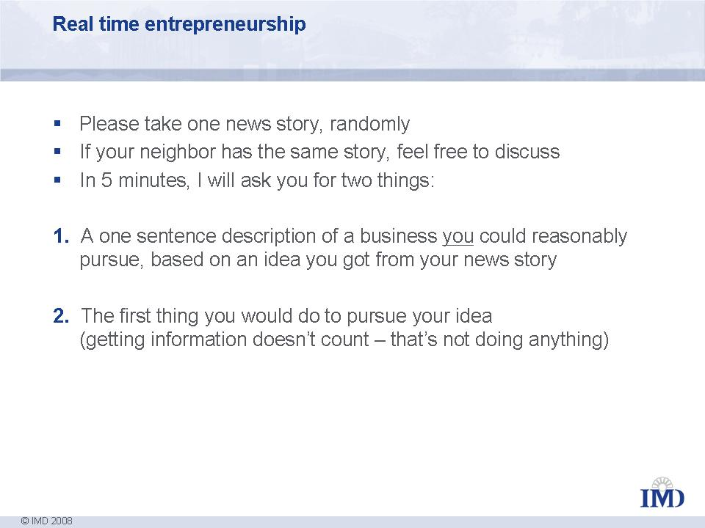

Exploring Opportunities
There is not much magic to running the debrief on the articles – exploring the articles that the students come up with. Push them to be concrete. Don’t let them get away with actions that are not really actions. Keep it lively. Encourage the playfulness which naturally emerges.

Collating Responses
By now most students will realize what they have seen. But for a clean wrap-up, there are a couple of important aspects to organizing the responses about the session.

The first is to organize responses according to whether they are relating to Ideas (be sure to put those responses on Board Right with the mass of ideas from the stories), versus Actions (be sure to put those responses on Board Left, with the inventory of generic action types). As you progress through the feedback from the group, you want to make sure that someone mentions each of the of following (or that you bring it out in the discussion):

Ideas come from everywhere
Ideas are cheap
Ideas are not just from technology
Constraints help the generation of ideas, not hurt
Ideas are a function of means (different people look at the same news story and come up with wildly different business ideas)

Action is what matters (see wrapup)
Action is always effectual (the generic action types will be a short list (sample follows) of actions that are built around the effectual notions of means (doing what I can with what I have) and partnerships (gaining commitments from prospective partner/stakeholders)

Sample list of generic action types:
- Try to sell a potential customer
- Try to get a commitment from a potential partner
- Build a prototype (with what I and my partners have, see point 2)
- Try to bring committed stakeholder employees into the venture (to expand the means available to the venture)

Wrap-up
The exercise is sufficiently self-evident that not much wrap-up is necessary. However, to drive the points home in a generalizeable way, we use the following:
"(Control is)...the characteristic of probability alterability. That is, if a participant could take steps to favorably alter the success rate in subsequent administrations of the task (not in the current administration), then the task is said to be characterized by control." (Goodie 2003:598)
Goodie tells us control is about two things.
1. People act on their perceptions of controllability in a situation (in uncertain situations, perceived control increases action/decisiveness).
2. Probabilities are alterable, really. Some strategies in some situations have an important impact on the creation of the future.
This view is tremendously empowering in the context of starting a new venture. Expert entrepreneurs will focus on areas where they feel they can influence the outcome. We already know some of the decision heuristics that experts employ to effect control. In this chapter, we will start with the basic formula for where new ventures come from.
So, where do viable ventures come from? They start with an idea. And ideas are nothing more than your transformation of anything (from rain - (see ICEHOTEL case to trash - Plas2Fuel (Appendix 8)):
IDEA = ANYTHING + YOU
But we also know that ideas, visions, or divine intervention alone are not what create opportunities. It is action:
OPPORTUNITY = IDEA + ACTION
Action is not gathering information. Action is proposing a deal with a client. Action is a discussing a product design with a supplier. Action is introducing a co-founder to the business. Action is not only outcome oriented, its also a function some kind of interaction with the world:
ACTION = Function (INTERACTION) on MONEY, PRODUCT, PARTNERS, CLIENTS, …
What turns these actions into a viable business is commitments.
Commitments are what mean revenue from customers, and what start the production line at a supplier:
VIABLE VENTURE = OPPORTUNITY + COMMITMENT

Appendix 1 (Article used April 2009)
US clinic offers custom-designed babies


US clinic offers custom-designed babies
March 4, 2009

Do you want blue eyes with your baby? That's one of the questions a US fertility clinic will be asking when it begins offering custom-designed babies to would-be mums and dads.
Dr Jeff Steinberg, who operates clinics in Manhattan and Los Angeles, said that within six months he planned to let customers choose their baby's eye, hair, and even skin colour, according to the New York Daily News.
Steinberg, who helped produce the first test-tube baby, acknowledged the technology was not 100 per cent perfect and said the best results had been achieved with couples with Scandinavian heritage, whose gene pools were least diluted.
Critics, though, have blasted the idea of designer babies, likening it to the pursuit of a master race.

Appendix 2 (Article used April 2009)

When Economy Sours, Tootsie Rolls Soothe Souls

When Economy Sours, Tootsie Rolls Soothe Souls
Christine Haughney, March 23, 2009
The recession seems to have a sweet tooth. As unemployment has risen and 401(k)’s have shrunk, Americans, particularly adults, have been consuming growing volumes of candy, from Mary Janes and Tootsie Rolls to Gummy Bears and cheap chocolates, say candy makers, store owners and industry experts.
Theories vary on exactly why. For many, sugar lifts spirits dragged low by the languishing economy. For others, candy also provides a nostalgic reminder of better times. And not insignificantly, it is relatively cheap.
At Candyality, a store in the Lakeview neighborhood of Chicago, business has jumped by nearly 80 percent compared with this time last year, and the owner, Terese McDonald, said she was struggling to keep up with the demand for Bit-O-Honeys, Swedish Fish and Sour Balls.
At the Candy Store in San Francisco, the owner, Diane Campbell, has tripled her orders for nostalgic candies like Necco Wafers and Mallo Cups in recent months. Many of her customers tell her that even though they are living on less, they’re setting aside cash for candy.
Many big candy makers are reporting rising sales and surprising profits even as manufacturers of other products are struggling to stay afloat. Cadbury reported a 30 percent rise in profits for 2008 while Nestle’s profits grew by 10.9 percent, according to public filings. Hershey, which struggled for much of 2008, saw profits jump by 8.5 percent in the fourth quarter.
Lindt & Sprüngli, which specializes in more expensive products like Lindt and Ghirardelli chocolate, announced that even though it expects to close some of its luxury retail stores this year, it also expects chocolate sales to remain strong through mainstream retailers like Wal-Mart and Target.
In Manhattan, at the sweet-smelling confines of Economy Candy on the Lower East Side, the owner, Jerry Cohen, said he increased his orders by 10 percent in January and February to keep up with demand for candies like Sugar Daddies and Sour Razzles. On a recent Sunday, Mr. Cohen had about a dozen workers in the narrow store trying to keep the candy tables and penny candy bins restocked as shoppers — the vast majority of them adults — grabbed candy bars and dug their hands into bins of Tootsie Rolls and Bit-O-Honeys.
Appendix 3 (Article used April 2009)
A Tentative New Hope for Discredited Cold Fusion


A Tentative New Hope for Discredited Cold Fusion
Discover Magazine, March 24
Cold fusion is the dream that won’t die for some nuclear physicists. If they could replicate the nuclear reaction that powers our sun under room temperature conditions, the thinking goes, humanity would gain a clean source of nearly limitless energy. Work on cold fusion has been relegated to the margins of science since a much-hyped experiment 20 years ago was discredited, but now a new team of researchers says they’ve conducted experiments that should reinstate the field. “We have compelling evidence that fusion reactions are occurring” at room temperature, said lead researcher Pamela Mosier-Boss, of the Space and Naval Warfare Systems Center in San Diego.
On March 23, 1989, physicists Stanley Pons and Martin Fleischmann claimed to have created fusion reactions in a tabletop experiment, at room temperature. Their claims of producing small amounts of excess heat — energy — in their experiments were at first met with excitement, then skepticism and finally derision as other scientists were unable to reproduce the results. Most physicists eventually concluded that the extra energy was either a fluke or the product of an experimental error.
Mosier-Boss announced her team’s new findings at a meeting of the American Chemical Society yesterday, twenty years to the day since the earlier declaration. She has also published the work in the journal Naturwissenschaft.
The theoretical underpinnings of cold fusion have yet to be adequately explained. The hypothesis is that when electrolysis is performed on [the heavy hydrogen isotope deuterium], molecules are fused into helium, releasing a high-energy neutron. While excess heat has been detected by researchers, no group had yet been able to detect the missing neutrons. But Mosier-Boss says that earlier experiments simply lacked the instruments to detect such a small number of neutrons.
Mosier-Boss says her team found the “tracks” left behind by high-energy neutrons, which, they suggest, emerge from the fusion of a deuterium and tritium atom. In their experiment, researchers exposed a special type of plastic to the reaction, and they say the excited neutrons carved three minute grooves in the material. However, the team didn’t prove conclusively that the neutrons were the product of fusion, and other researchers say the subatomic particles could have been created in some other, unknown nuclear reaction. For now, the debate over cold fusion will continue.

Appendix 4 (Article used April 2009)
When your mortgage application is rejected


When your mortgage application is rejected
(Nearly half of applicants turned down)

Bankrate.com March 22, 2009
Don't be surprised if your friendly lender, the one who invites you to sit down and apply for a mortgage, ushers you politely out the door empty-handed after you've chatted a bit.
The sudden chill isn't personal. The Mortgage Bankers Association, or MBA, in Washington, D.C., estimates that about half of all mortgage applicants are now being turned down. Though refinancing approvals remained static, the acceptance rate on mortgage applications suffered a 10 percentage-point drop, from 63 percent in the first half of 2007 to 53 percent in the first half of last year, according to mortgage data tracked semi-annually by the association. Since then, further tightening of credit standards means at least half of mortgage-seeking consumers can't squeeze through to acceptance, says MBA spokeswoman Carolyn Kemp.

Appendix 5 (Article used April 2009)
Quantum nonlocality


Quantum nonlocality
http://www.braungardt.com/Physics/Quantum%20Nonlocality.htm
Quantum nonlocality is a paradox that was described first by Einstein, Podolsky, and Rosen (EPR), who published the idea in 1935. The EPR paradox draws attention to a phenomenon predicted by quantum mechanics known as quantum entanglement, in which measurements on spatially separated quantum systems can instantaneously influence one another. As a result, quantum mechanics violates a principle formulated by Einstein, known as the principle of locality or local realism, which states that changes performed on one physical system should have no immediate effect on another spatially separated system.
At the quantum level, instantaneous actions occur at a distance. Two particles that are part of a single system continue to act in concert with one another no matter how far apart they appear to be separated by spacetime.
Nonlocality or nonseparability is asking us to revise completely our ideas about objects, to remove a pervasive projection we have upon nature. We can no longer consider objects as independently existing entities that can be localized in well-defined regions of spacetime. They are interconnected in ways not even conceivable using ideas from classical physics, which is largely a refinement and extrapolation from our normal macroscopic sense of functioning. (Mansfield, 1995, p.122).
Quantum nonlocality proves that "particles that were once together in an interaction remain in some sense parts of a single system which responds together to further interactions". Since the entire universe originated in a flash of light known as the Big Bang, the existence of quantum nonlocality points toward a profound cosmological holism and suggests that every particle in every star and galaxy that we can see "knows" about the existence of every other particle (Gribbin, 1984).

Appendix 6 (Article used April 2009)
Indian Geek Develops 'Sixth Sense' Device



Indian Geek Develops 'Sixth Sense' Device
Use hand gestures to click pictures or send mails
Mar 25, 2009
28-year-old Pranav Mistry, a MIT (Massachusetts Institute of Technology) based researcher hailing from Gujarat has created a digital prototype of a "sixth sense" device that is being currently evaluated by corporations including Google, Microsoft, HP and Samsung.
To briefly describe what this sixth sense is all about, we need to understand how the current dissemination of information from current electronic devices takes place. Most of the information from computers, mobile phones and other devices are confined to screen or paper - if we decide to take a print. However, the sixth sense, according to Mistry, bridges this gap "bringing intangible digital information out into the tangible world, and allowing us to interact with this information via natural hand gestures". The concept falls under "wearable computing" -- the same category under which the ubiquitous mobile phone falls as well.
The equipment list for the sixth sense might seem a tad crude, but it does its job quite well. It comprises a pocket projector; mirror and web camera bundled in a wearable pendant-like mobile. With the help of the projector, you can turn any material surface into a touchscreen. The camera is used to "see" the hand gestures. The user will however need to wear color-coded gloves on the index finger and the thumb so that the hand movements can be recorded and decrypted.
Some of the interesting hand gestures include drawing a square frame which will trigger a command to take a picture, drawing the @ sign will let the user access his email. You can even write e-mails with the help of the projector, which projects an image of a virtual keyboard so that you can type. All this costs around $350 (Rs. 17,000) to build - which is not a bad for something as futuristic as this!
Mistry has been approached by a couple of Indian companies who seem to be interested in his project. However, he wants the technology to be a little cheaper before it comes to India.

Appendix 7 (Article used April 2009)
How much water does it take to make a cup of coffee?


How much water does it take to make a cup of coffee?
April 3, 2008, www.newzity.com
Answer: 37 gallons.
8 ounces are used to actually brew the coffee, and the rest to grow, process, package and ship the beans.
Unlike traditional measures of water consumption, water footprint measures the total volume of freshwater used in making a product, giving a fresh perspective to the amount of water consumed by individuals, businesses and nations. Here’s the water footprint for a few other common items:
- 800 gallons for a gallon of milk
- 1340 gallons for a pound of wheat
- 9300 gallons for a pound of beef.
- 2.5 gallons for a single sheet of paper
- 7 gallons for a gallon of bottled water
Only around two per cent of the world’s water is drinkable, with 65 per cent of that permanently locked away, frozen within glaciers and at the poles. With water projected to become scarcer in the 21st century, and wars expected to be fought over it, water footprint can be predicted to become a part of popular conscience in the near future.

Appendix 8 (Article on Plas2Fuel)
